Disclaimer: I DO NOT claim or guarantee whether the answer written here is 100% accurate. If you feel something is not accurate or out-of-order or want to contribute, it will be a great help, if you let me know. Question which are crossed refers to the repeated question which has been answered already but this rule hasn’t been applied to all repeated question. Use Chrome to read this PDF properly. All question are from Pokhara University board exam papers of BCA.
Author: Pranav Bhattarai

Fall 2021
1 a) What is computer network? Discuss the merits and demerits of computer network with suitable example.
1 b) Explain about different types of transmission impairments.
2 a) Explain wavelength division multiplexing.
2 b) What is reference model? Explain the function of the different layers of the OSI reference model.
3 a) Give introduction of optical fiber and twisted pair cable in short and suggest which one among the two is better for today’s wired communications. Why?
3 b) Explain the issues of data link layer.
4 a) Explain the causes of error in transmission? How can error be detected using cyclic redundancy check method? Explain with example.
4 b) What is congestion? Explain the leaky bucket congestion control algorithm with suitable diagram.
5 a) Explain the IPV6 header.
5 b) Explain ICMP, IGMP and RIP protocols.
6 a) Explain the role of proxy server.
6 b) Explain DHCP process with figure.
6 c) Explain public key encryption and private key encryption.
7. Write short notes on any two:
a) Mobile IP
b) Leaky Bucket Algorithm
c) Packet Switching and Circuit Switching

Fall 2019

1 a) What do you mean by computer network? Explain client-server and peer-to-peer model of network.
1 b) How attenuation and distortion affect the quality of communication? Explain.
2 a) What do you mean by modulation? Explain amplitude modulation with advantages and disadvantages.

2 b) What is the purpose of Presentation layer in OSI reference model? How TCP/IP model is working without the Session and Presentation layer? Explain.

The purpose of Presentation layer (layer 6) in OSI reference model is:
- It is used to present data to the application layer (layer 7) in an accurate, well-defined and standardized format.

TCP/IP model is working without the Session and Presentation layer because the Application layer is responsible for all the function that are preformed by Presentation and Session layers in the OSI model.

TCP/IP does not have a separate Presentation layer or Session layer…...

3 a) What do you mean by radio wave and microwave? Write the difference between satellite and terrestrial system.
Ans:
- Radio waves are electromagnetic waves within the frequencies 30KHz - 300GHz, and include microwaves.
- Microwaves are electromagnetic waves with frequencies between 300MHz (0.3GHz) and 300GHz in the electromagnetic spectrum.

Microwave communication systems are mainly classified into satellite systems and terrestrial systems. The differences between this two system are enlisted down below:
Satellite System Vs Terrestrial System
- Coverage area of satellite system is greater then terrestrial system. A GEO satellite with one single antenna can cover about 1/4th of the earth.
- Satellite communications link will have more degradation's compare to terrestrial communication link but quality of transmission is usually quite good.
- In a satellite link delay from earth to satellite to earth is about 240ms while in terrestrial link it will be far less. But transmission cost in a satellite system is independent of the distance within the area of coverage of the satellite antenna, while in terrestrial system it varies based on the distance.
- In a satellite based system satellite EIRP and bandwidth is very vital parameters which need to be carefully designed at the initial stage of both satellite and earth station point of view. In terrestrial system, modification are be done easily without future predication because they can be reached easily.
- Very high bandwidths and very high data rates are achievable in a satellite based communication system. In terrestrial based communication, there is so many hurdles to achieve this. But that doesn’t mean its impossible.
- In case of satellite based systems all the earth stations/VSATs can receive their own transmissions and hence transmitted power should be carefully decided based on the RF link budget. But both transmitting and receiving frequencies are different and hence will not create much problem. Transmit reject filter should be good enough to overcome this problem.

Note: EIRP = Effective Isotropic Radiated Power

3 b) Given a data word 1010011110 and the divisor polynomial X⁴+X²+X+1,v
i. Show the generation of codeword at sender site (using binary division)
ii. Show the checking of codeword at receiver site (assuming no error)

Solution:

4 a) Explain IPv6 address structure and differentiate between IPv4 and IPv6.

IPv4 | IPv6
Internet Protocol version 4 (IPv4) is the fourth version of Internet Protocol (IP) and was initially published in 1981, | Internet Protocol version 6 (IPv6) is the sixth version of internet protocol and became a draft standard in 1998.
IPv4 is a 32 bit IP address. | IPv6 is a 128 bit IP address.
It offers supports to Virtual Length Subnet Mask. | There is no offers support provided for VLSM in case of IPv6.
IPv6 provides much better Multicast and Anycast abilities than IPv4.

4 b) If two computers A and B are assigned with IP-Address 172.16.17.30/20 and 172.16.28.15/22. Find the subnet addresses they belong and determine whether they belong to same or different subnets.
5 a) What do you mean by routing? Explain static and dynamic routing with advantages and disadvantages.

5 b) What are the reasons for congestion in network? How Leaky Bucket algorithm control the congestion in network. Explain.
6 a) What does CIA triad of information security mean? Explain in brief.
Confidentiality, integrity and availability, also known as the CIA triad, is a model designed to guide policies for information security within an organization. The model is also sometimes referred to as the AIC triad (availability, integrity and confidentiality) to avoid confusion with the Central Intelligence Agency. The elements of the triad are considered the three most crucial components of security.

In this context, confidentiality is a set of rules that limits access to information, integrity is the assurance that the information is trustworthy and accurate, and availability is a guarantee of reliable access to the information by authorized people.

6 b) Explain the DORA (Discover, Offer, Request and Acknowledge) process of DHCP.
7. Write short notes on any two:
a) Packet Switching

b) Hamming Code

Hamming code is a block code that is capable of detecting up to two simultaneous bit errors and correcting single-bit errors. It was developed by R.W. Hamming for error correction.

In this coding method, the source encodes the message by inserting redundant bits within the message. These redundant bits are extra bits that are generated and inserted at specific positions in the message itself to enable error detection and correction. When the destination receives this message, it performs recalculations to detect errors and find the bit position that has error.

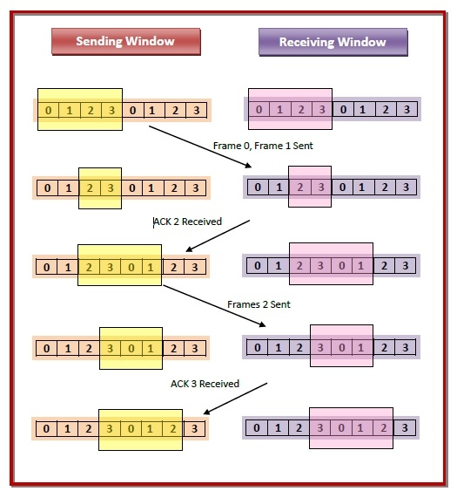
c) Sliding Window Protocol

Sliding window protocols are data link layer protocols for reliable and sequential delivery of data frames. The sliding window is also used in Transmission Control Protocol.

In this protocol, multiple frames can be sent by a sender at a time before receiving an acknowledgment from the receiver. The term sliding window refers to the imaginary boxes to hold frames. Sliding window method is also known as windowing.

Suppose that we have sender window and receiver window each of size 4. So the sequence numbering of both the windows will be 0,1,2,3,0,1,2 and so on. The following diagram shows the positions of the windows after sending the frames and receiving acknowledgments.

Spring, 2018

1 a) State pros and cons of Computer Network. Explain different Computer network models.
Pros of computer network are:
- Files can be shared easily between users.
- Data is easy to backup as all the data is stored on the file server.
- Security is good - users cannot see other users' files unlike on stand-alone machines.
- Network users can communicate by email and instant messenger.
- Site (software) licenses are likely to be cheaper than buying several standalone licenses.

Cons of computer network are:
- Purchasing the network cabling and file servers can be expensive.
- Managing a large computer network is complicated, requires training and a network manager usually needs to be employed.
- If the file server breaks down the files on the file server become inaccessible.
- Viruses can spread to other computers throughout a computer network.
- There is a danger of hacking, particularly with wide area networks. Security procedures are needed to prevent such abuse, eg a firewall.

Different computer network models are:
a) OSI Model:
OSI stands for Open System Interconnection.
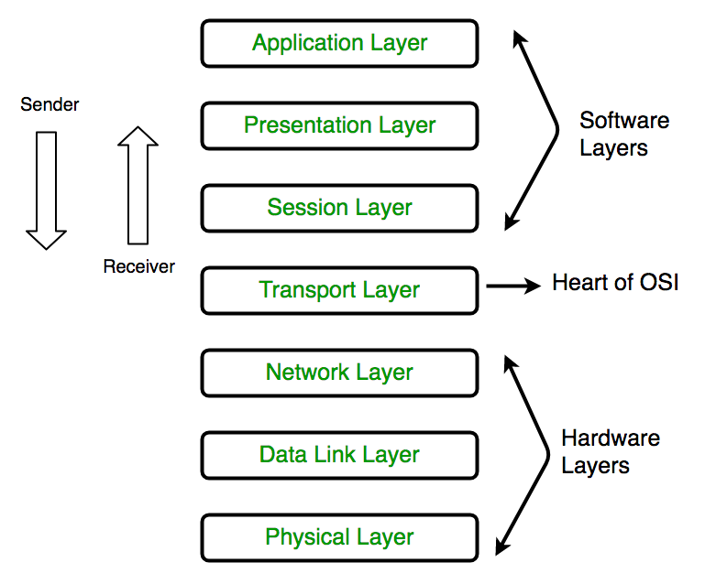
- The OSI Model is one of the general purpose networking or communication model among computer network models, which is responsible for establishing connection in an open manner between all the communicable devices present across the globe.

- OSI model is called as “Open Source” because of its “fit anywhere” ability. Any connection can be established using the OSI model unless and until any protocols are not used as OSI model does not support protocol establishment. It runs without the use of protocols. All the networking devices which are open for communication can be connected together for data communication through the OSI model.

- OSI model having a layered architecture, allows easy data communication as each layer has predefined structured and functionalities. The 7 layers which OSI model contains are enlisted down below:

- Physical Layer (Layer 1) : The lowest layer of the OSI reference model is the physical layer. It is responsible for the actual physical connection between the devices. It contains information in the form of bits. It is responsible for the actual physical connection between the devices. When receiving data, this layer will get the signal received and convert it into 0s and 1s and send them to the Data Link layer, which will put the frame back together. Function of the physical layer are :
  - Bit synchronization: The physical layer provides the synchronization of the bits by providing a clock. This clock controls both sender and receiver thus providing synchronization at bit level.
  - Bit rate control: The Physical layer also defines the transmission rate i.e. the number of bits sent per second.
  - Physical topologies: Physical layer specifies the way in which the different, devices/nodes are arranged in a network i.e. bus, star or mesh topology.
  - Transmission mode: Physical layer also defines the way in which the data flows between the two connected devices. The various transmission modes possible are: Simplex, half-duplex and full-duplex.

Note: Hub, Repeater, Modem, Cables are Physical Layer devices.

- Data Link Layer (Layer 2): The data link layer is responsible for the node to node delivery of the message. The main function of this layer is to make sure data transfer is error free from one node to another, over the physical layer. When a packet arrives in a network, it is the responsibility of DLL to transmit it to the Host using its MAC address.
Data Link Layer is divided into two sub layers :
Logical Link Control (LLC): It controls frame synchronization, flow control and error checking.
Media Access Control (MAC): It is responsible for moving data packets to and from one Network Interface Card (NIC) to another across a shared channel.
The functions of the data Link layer are :
    - Framing: Framing is a function of the data link layer. It provides a way for a sender to transmit a set of bits that are meaningful to the receiver. This can be accomplished by attaching special bit patterns to the beginning and end of the frame.
    - Physical addressing: After creating frames, Data link layer adds physical addresses (MAC address) of sender and/or receiver in the header of each frame.
    - Error control: Data link layer provides the mechanism of error control in which it detects and retransmits damaged or lost frames.
    - Flow Control: The data rate must be constant on both sides else the data may get corrupted thus , flow control coordinates that amount of data that can be sent before receiving acknowledgment.
    - Access control: When a single communication channel is shared by multiple devices, MAC sub-layer of data link layer helps to determine which device has control over the channel at a given time.
Note:
Packet in Data Link layer is referred as Frame.
Data Link layer is handled by the NIC (Network Interface Card) and device drivers of host machines.
Switch & Bridge are Data Link Layer devices.

- Network Layer (Layer 3): Network layer works for the transmission of data from one host to the other located in different networks. It also takes care of packet routing i.e. selection of the shortest path to transmit the packet, from the number of routes available. The sender & receiver’s IP address are placed in the header by network layer.
The functions of the Network layer are :
- Routing: The network layer protocols determine which route is suitable from source to destination. This function of network layer is known as routing.
- Logical Addressing: In order to identify each device on inter-network (i.e a network of network) uniquely, network layer defines an addressing scheme. The sender & receiver’s IP address are placed in the header by network layer. Such an address distinguishes each device uniquely and universally.
Note:
Segment in Network layer is referred as Packet.
Network layer is implemented by networking devices such as routers.

- Transport Layer (Layer 4): It is the middle most layer in OSI model and it acts as Network Independent Layer. It has no idea about the functioning of lower layer i.e. physical, data link and network layers.

- Session Layer (Layer 5): It is the fifth layer of OSI model and it provides appropriate sessions between users and entities, where user interacts. This layer can be used on the basis of resources available and it can be skipped too if not required. For example : Login Sessions in online banking.

- Presentation Layer (Layer 6): It is the sixth layer of OSI model and it provides appropriate representation of data through various data presentation techniques.
vii. Application Layer (Layer 7): It is the topmost layer of the OSI model and has the responsibility for providing interface between various users and application.

b) TCP/IP Model:
TCP/IP, or the Transmission Control Protocol/Internet Protocol, is a suite of communication protocols used to interconnect network devices on the internet. TCP/IP can also be used as a communications protocol in a private network (an intranet or an extranet).
TCP/IP specifies how data is exchanged over the internet by providing end-to-end communications that identify how it should be broken into packets, addressed, transmitted, routed and received at the destination. TCP/IP requires little central management, and it is designed to make networks reliable, with the ability to recover automatically from the failure of any device on the network.

The two main protocols in the internet protocol suite serve specific functions. TCP defines how applications can create channels of communication across a network. It also manages how a message is assembled into smaller packets before they are then transmitted over the internet and reassembled in the right order at the destination address.
IP defines how to address and route each packet to make sure it reaches the right destination. Each gateway computer on the network checks this IP address to determine where to forward the message.
TCP/IP functionality is divided into four layers, each of which include specific protocols.
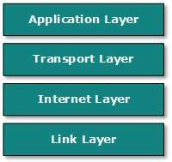
i) Application layer This layer defines the protocol which enables user to interact with the network. For example, FTP, HTTP etc.

ii) Transport layer This layer defines how data should flow between hosts. Major protocol at this layer is Transmission Control Protocol (TCP). This layer ensures data delivered between hosts is in-order and is responsible for end-to-end delivery.

iii) Internet Layer, also called the Network layer, deals with packets and connects independent networks to transport the packets across network boundaries. The network layer protocols are the IP and the Internet Control Message Protocol (ICMP), which is used for error reporting.

iv) Physical layer consists of protocols that operate only on a link -- the network component that interconnects nodes or hosts in the network. The protocols in this layer include Ethernet for local area networks (LANs) and the Address Resolution Protocol

1 b) What is transmission impairments? State and explain in brief different factors of transmission impairments.
Signals travels through transmission media, which are not perfect. The imperfection causes signal impairment. This means that the signal at the beginning of the medium is not the same as the signal at the end of the medium received. This situation is what we call transmission impairments.

Different factors of transmission impairments are:
- Attenuation: It means loss of energy. When a signal travel through a medium, it loses some of its energy in overcoming the resistance of medium. That is why a wire carrying electric signal gets warm. To compensate this loss, amplifiers are used to amplify the signal. To show that a signal has lost or gained strength, engineers use the SI unit of the decibel.

- Distortion: It means that the signal changes its form or shape. This is generally seen in composite signals with different frequencies. Each frequency component has its own propagation speed traveling through a medium. Every component arrive at different time which leads to delay distortion. Therefore, they have different phases at receiver end from what they had at senders end.

- Noise: The random or unwanted signal that mixes up with the original signal is called noise. There are four types of it which may corrupt the signal.
- Induced noise: Induced noise comes from sources such as motors and appliances. These devices act as sending antenna and transmission medium act as receiving antenna.

- Crosstalk noise: Crosstalk is a disturbance caused by the electric or magnetic fields of one telecommunication signal affecting a signal in an adjacent circuit. In an telephone circuit, crosstalk can result in your hearing part of a voice conversation from another circuit.

- Thermal noise: Thermal noise is movement of electrons in wire which creates an extra signal.
- Impulse noise: Impulse noise is a signal with high energy that comes from lightning or power lines

2 a) What is switching? Make comparison between circuit switching and packet switching.
Switching is process to forward packets coming in from one port to a port leading towards the destination.
Circuit Switching | Packet Switching
It is connection oriented. | It is connection-less.
It is inflexible, because once a path is set all parts of a transmission follows the same path. | It is flexible, because a route is created for each packet to travel to the destination.
Message is received in the order, sent from the source. | Packets of a message are received out of order and assembled at the destination.
Circuit switching can be achieved using two technologies, either Space Division Switching or Time-Division Switching. | Packet Switching has two approaches Datagram Approach and Virtual Circuit Approach.
Circuit Switching is implemented at Physical Layer. | Packet Switching is implemented at Network Layer.
For Data transmission, Packet Switching is the more efficient than Circuit Switching whereas, when it comes to voice transmission Circuit switching is more efficient than packet switching.

2 b) What is OSI reference model? Explain its layers with clear diagram.
Open System Interconnect is an open standard for all communication systems. OSI model is established by International Standard Organization (ISO). This model has seven layers:
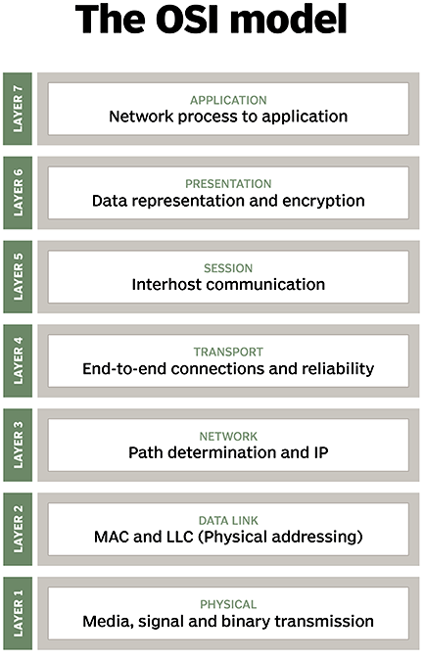
- Application Layer: This layer is responsible for providing interface to the application user. This layer encompasses protocols which directly interact with the user.

- Presentation Layer: This layer defines how data in the native format of remote host should be presented in the native format of host.

- Session Layer: This layer maintains sessions between remote hosts. For example, once user/password authentication is done, the remote host maintains this session for a while and does not ask for authentication again in that time span.

- Transport Layer: This layer is responsible for end-to-end delivery between hosts.

- Network Layer: This layer is responsible for address assignment and uniquely addressing hosts in a network.

- Data Link Layer: This layer is responsible for reading and writing data from and onto the line. Link errors are detected at this layer.

- Physical Layer: This layer defines the hardware, cabling wiring, power output, pulse rate etc.

3 a) What is data transmission media? How ISDN is different from PSTN?
Data transmission media is the physical media/device over which communication takes place in computer networks. For example, twisted pair cable, coaxial cable, fiber optics, etc.
ISDN is different from PSTN because of following points:
ISDN (Integrated Services Digital Network) | PSTN (Public Switched Telephone Network)
ISDN lines are digital. | PSTN lines are analog.
They are used for big companies. | They are used for small companies.
With ISDN, one can run as many as 2, 10, 20 or 30 channels that could be run with a single line. | PSTN are mostly used as single lines for firms or companies that need ADSL.
ISDN provides 128 kbps, which is really good for the Internet. | PSTN has a disadvantage that it does not make the most possible use of the broadband.
Two simultaneous connections are allowed in ISDN. | PSTN does not allow two simultaneous connections

3 b) Calculate CRC for 10 bit sequence 1010011010. The generator polynomial is x^3+x+1.

4 a) What is unicasting and multicasting? Explain in brief about mobile IP frame format.
Unicasting is communication between a single sender and a single receiver over a network.
Multicasting is communication between a single sender and multiple receivers over a network.

4 b) A company is uses the ip address 197.70.64.10/9. What does it mean? Explain in brief about all the factors related with it.
5 a) What is sliding window protocal? Explain it with diagram.
5 b) Define routing. Difference between distance vector routing algorithm and flow based routing algorithm.
6 a) Explain the working process of DNS and DHCP with suitable example.
6 b) What are the necessity of cryptography in communication? Explain in brief about public key algorithm.
7. Write short notes on any two:
a) Internet multicasting
b) Leaky Bucket Algorithm:
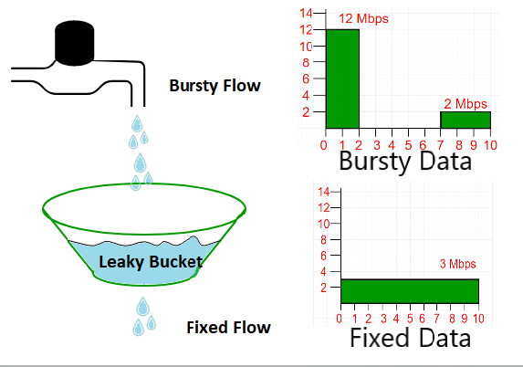

c) FTP:
File Transfer Protocol (FTP) is a client/server protocol used for transferring files to or exchanging files with a host computer. It may be authenticated with user names and passwords. Anonymous FTP allows users to access files, programs and other data from the Internet without the need for a user ID or password. Web sites are sometimes designed to allow users to use 'anonymous' or 'guest' as a user ID and an email address for a password. Publicly available flies are often found in a directory called pub and can be easily FTPed to a user’s computer. FTP is also the Internet standard for moving or transferring files from one computer to another using TCP or IP networks.

Fall 2018
1 a) What is computer network? Write down the application areas of computer networks in modern society.
1 b) What are transmission impairment? Differentiate between synchronous and asynchronous transmission.
2 a) Why modification technique is important in data communication? Explain different types of modulation technique use in computer network.
2 b) What do you mean by protocol stack? Draw and explain working principal of OSI reference model.
3 a) What is transmission media? Explain the different types of transmission media use in computer network.
3 b) Describe the frame format of IPV6 and explain for each fields.
4 a) What is cryptography? Explain the symmetric key algorithm and public key algorithm method.
Cryptography is a method of protecting information and communications through the use of codes/algorithm so that only those for whom the information is intended can read and process it. The prefix "crypt" means "hidden" and the suffix "graphy" stands for "writing."
Transformed unreadable data is called encrypted data which is almost impossible to decipher by third person like hackers.

Symmetric-key algorithms (aka secret key algorithm) are algorithms for cryptography that use the same cryptographic keys for both encryption of plain-text and decryption of cipher-text. It is a two-way algorithm because the mathematical algorithm is reversed when decryption the message along with using the same secret key.
It is also known as private-key encryption and secure-key encryption.

A very simple example of how a symmetric key algorithm might work might be substituting the letter in the alphabet prior to the target letter for each one in a message. The resulting text - "gdkkn," for example - would make no sense to someone who didn't know the algorithm used (x-1), but would be easily understood by the parties involved in the exchange as "hello."

The problem with symmetric keys is how to securely get the secret keys to each end of the exchange party and keep them secure after that. For this reason, an public key algorithm is now often.

Public key algorithm (aka asymmetric key algorithm)

4 b) What do you mean by Routing? Explain shortest path Routing Algorithm and Flow based Routine Algorithm.
5 a) What is framing? Show the error correction by using CRC method on data 1110101 with generated polynomial equation.
5 b) You are given an IP address 172.80.10.0/18. As a network engineer design the possible subnets. Also calculate subnet mask, each network address, broadcast address and range of host IPs for each subnet.
6 a) What are the reasons for correction in network? Explain any one congestion control algorithm.

6 b) Write short notes on: Proxy server, Firewall and DHCP server.
Proxy server:
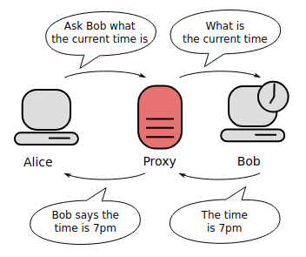
A proxy server is a server (a computer system or an application) that acts as an intermediary for requests from clients seeking resources from other servers. A client connects to the proxy server, requesting some service, such as a file, connection, web page, or other resource available from a different server and the proxy server evaluates the request as a way to simplify and control its complexity. Proxies were invented to add structure and encapsulation to distributed systems.

So, how proxy operates?
Proxy server is a computer on the web that redirects your web browsing activity. Here's what that means.
- Normally, when you type in a website name (Amazon.com or any other), your Internet Service Provider (ISP) makes the request for you and connects you with the destination—and reveals your real IP address.
- When you use a proxy your online requests get rerouted.
- While using a proxy, your Internet request goes from your computer to your ISP as usual, but then gets sent to the proxy server, and then to the website/destination. Along the way, the proxy uses the IP address you chose in your setup, masking your real IP address.

Fig: Demonstration of how proxy server works. (Note that here “Alice” is just a computer users who is asking for some information and “Bob” is a web server replaying some information asked by the user.)

7. Write short notes on any two:
a) Selective repeat ARQ:
is the sliding window ARQ protocol which detects or corrects the error occurred in data layer. This protocol re-transmits that frame which is damaged or lost. The re-transmitted framed is received out in sequence.

b) Circuit Switching
is a method of implementing a telecommunications network in which two network nodes establish a dedicated communication channel (circuit) through the network before the nodes may communicate.
Circuit switching systems are ideal for communication that are require data to be transmitted in real-time. These networks are also called correction-oriented networks.

c) Hamming Code:
is a set of error correction codes that can be used to detect and correct bit errors that occur when data is moved or stored from sender to receiver.
It is developed by R.W. Hamming. It can detect upto 2 bits errors or correct 1 bit error without detection of uncorrected errors, and can detect only an odd number of bits in error.
Like other error detection code, hamming code makes use of the concept of parity and parity bits, which are bits that are added to data so that the validity of the data can be checked when it is read or after it has been received in data transmission.

2017 Spring

1 a) What is computer network? Write down the application areas of computer network.
1 b) Define frequency and bandwidth. Difference between synchronous and asynchronous transmission.
Synchronous Transmission | Asynchronous Transmission
Full duplex mode. | Half duplex.
Block pattern transmission. | Bit pattern transmission.
Require clock signal. | Doesn’t require clock signal.
Faster way of data transmission. | Slower way of data transmission.
Time interval is random. | Time interval is constant.
Complex & expensive. | Simple and economical.

2 a) What is angle modulation? Differentiate among message switching, circuit switching and packet switching.
2 b) What are protocols? Define the terms: Hub, Bridge, switch and repeater.

3 a) What is LOS communication? What are the difference between satellite and optical fiber communication?

Lines of Side (LOS) is a type of propagation that can transmit and receive data only where transmit and receive stations are in view of each other without any sort of an obstacle between them. FM, radio, microwave and satellite communication are examples of LOS communications.

3 b) What is error control? Explain in detail about Go-Back-N ARQ mechanism for error control.
4 a) Describe the parity and checksum error detection method with examples.
4 b) Describe the parity and checksum error detection methods with examples.
5 a) For the given IP address 192.168.10.0/25, find the total hosts, total subnets, total usable hosts and also calculate the IP address range of all subnets.
5 b) Explain the various classes of IPV4.
IANA (Internet Assigned Numbers Authority) defined five classes of public IP as shown below:
Class | Theoretical Address Range | Binary Start | Used for
A | 0.0.0.0 to 127.255.255.255 | 0 | Very large network
B | 128.0.0.0 to 191.255.255.255 | 10 | Medium network
C | 192.0.0.0 to 223.255.255.255 | 110 | Small network
D | 224.0.0.0 to 239.255.255.255 | 1110 | Multicast
E | 240.0.0.0 to 247.255.255.255 | 1111 | Experiment

6 a) What do you understand by Routing? Discuss about the working of shortest path routing Algorithm.
6 b) How leaky bucket algorithm help the congestion control in data communication?
7. Write short notes on any two:
a)Proxy server
b) Private key cryptography
c) Internet protocol stack

Fall 2017

1 a) What is computer network? Different between peer to peer network and client-server network.
1 b) What are transmission impairments? Explain various causes of impairments.
2 a) Why modulation is required for data transmission? Describe briefly the terms: PWM, PPM, PAM and PCM.
2 b) What are the logical protocols? Explain the layers of OSI reference model with its architecture.
3 a) What are the advantages of optical fiber? Different between base band and broad band coaxial cables.
3 b) What is the meaning of flow control and error control? Explain in detail about Stop-and-Wait ARQ mechanism for error control.
4 a) Describe the parity and checksum error detection methods with examples.
4 b) Explain IPV6 in brief with header format.
5 a) Given IP address 156.154.81.56/26, calculate the total IP address, usable IP address, the subnet mask, network address and broadcast address.
5 b) What is internet multicasting? What are the difference between OSI reference model and TCP/IP model?
6 a) What do mean by static routing and dynamic routing? Explain Dijkstra’s shortest path routing algorithm.
6 b) How leaky bucket algorithm help in congestion control during data transmission?
7. Write short notes on any two:
a) HTTP
b) Asymmetric key cryptography
c) Difference between hub and repeater

Spring 2015

1 a) What is client server model? How is it differs from peer to peer network model?
1 b) How can you define the bandwidth of the system? What are the differences between synchronous and asynchronous transmission?
2 a) Why data modulation is used in computer networks? Explain different types of modulation techniques used.
2 b) What is OSI reference model? Explain its layering function with diagram.
3 a) What are transmission media? Explain different types of transmission media use in computer network.
3 b) How errors are occurred in network? Write the error detection and correction method in data link layer.
4 a) What is framing? Show the error correction by using CRC method on data 1101110 with generation polynomial x³+1 equation.
Framing is a point-to-point connection between two computers or devices consists of a wire in which data is transmitted as a stream of bits. It is the function of data link layer. It provides a way for a sender to transmit a set of set of bits that are meaningful

4 b) What is sub netting? Calculate total number of usable IP from given IP 75.35.162.128/27.
5 a) Compare the frame format of IPV4 and IPV6 with diagram.
5 b) What is adaptive routing table? Explain distance vector routing.
6 a) Differentiate between Virtual Circuit and Datagram with suitable example.

6 b) Define Cryptography. Explain the symmetric key algorithm and public key algorithm method.

7) Write short on:
i) Mobile IP: Mobile IP (or MIP) is an Internet Engineering Task Force (IETF) standard communications protocol that is designed to allow mobile device users to move from one network to another while maintaining a permanent IP address.
This standard that allows users with mobile devices whose IP addresses are associated with one network to stay connected when moving to a network with a different IP address. When a user leaves the network with which his device is associated (home network) and enters the domain of a foreign network, the foreign network uses the Mobile IP protocol to inform the home network of a care-of address to which all packets for the user's device should be sent.

Mobile IP is most often found in wireless WAN environments where users need to carry their mobile devices across multiple LANs with different IP addresses.

A common analogy to explain Mobile IP is when someone moves his residence from one location to another. Person moves from Boston to New York. Person drops off new mailing address to New York post office. New York post office notifies Boston post office of new mailing address. When Boston post office receives mail for person it knows to forward mail to person's New York address.

ii) DNS server: A DNS server is a computer server that contains a database of public IP addresses and their associated host-names, and in most cases serves to resolve, or translate, those names to IP addresses as requested. DNS servers run special software and communicate with each other using special protocols.
The Purpose of DNS Servers is that it is easier to remember a domain or hostname like bbc.com than it is to remember the site's IP address numbers 38.160.150.31.

iii) Proxy Server:

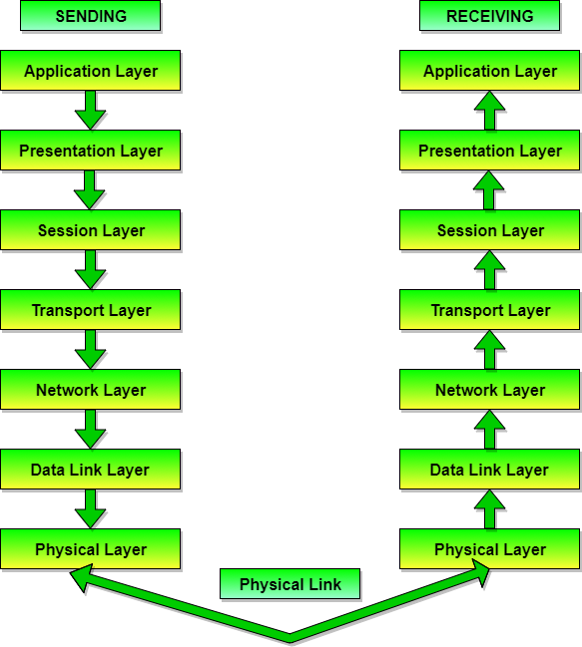
Fig: Data transfer in OSI model

